**Steering Wheel Repair Data Analysis Report**

**1. Column Analysis**

The dataset contains **100 records** and **63 columns**, focusing on steering wheel-related repairs. Below are key columns critical for analysis:

* **REPAIR_DATE**: Tracks when repairs occurred, helpful in identifying seasonal trends.
* **GLOBAL_LABOR_CODE_DESCRIPTION**: Provides standardized descriptions of performed repairs, highlighting failure patterns.
* **PLATFORM**: Identifies vehicle categories (e.g., Full-Size Trucks, BEVs) with frequent steering issues.
* **REPAIR_AGE**: Shows how early steering problems occur, indicating potential manufacturing or material defects.
* **TOTALCOST**: Offers insight into financial impact, crucial for warranty cost assessment.

Additional columns such as **VIN, TRANSACTION_ID, DEALER_NAME**, and **CUSTOMER_VERBATIM** support deeper investigation into failure causes and geographic trends.

**2. Data Cleaning Summary**

To ensure consistency and accuracy, the following preprocessing steps were applied:

* **Handling Missing Values**: Columns with more than 70% missing data were removed. Missing numerical values were imputed using the median, while categorical values used the most frequent entry.
* **Standardizing Text Data**: Text fields were cleaned by removing unnecessary spaces, correcting spelling errors, and ensuring consistent formatting.
* **Detecting and Managing Outliers**: Outliers in numerical fields (such as **TOTALCOST** and **KM Driven**) were capped using the IQR method.
* **Duplicate Removal**: Identified duplicates using a combination of VIN and REPAIR_DATE, ensuring only unique repair records were retained.

Finalized data was stored in **cleaned_data.csv**, prepared for further analysis.

## ****3. Visualizations & Extracted Insights****

**Common Steering Wheel Issues**

* **Material defects**: Leather peeling, stitching failures.
* **Electrical failures**: Heated wheel malfunction, horn switch issues.
* **Mechanical faults**: Steering misalignment, clicking/rubbing noises.

**Most Affected Vehicle Types**

* **Full-Size Trucks** (especially Crew Cab models).
* **BEVs** (Battery Electric Vehicles).
* **Full-Size Utility vehicles**.

**Repair Frequency & Cost Trends**

* **Repairs mostly occur within the first year**, indicating early wear or manufacturing-related issues.
* **Costs range from $27.69 to $1,656.85**, with **labor expenses accounting for 20-30%** of the total repair cost.

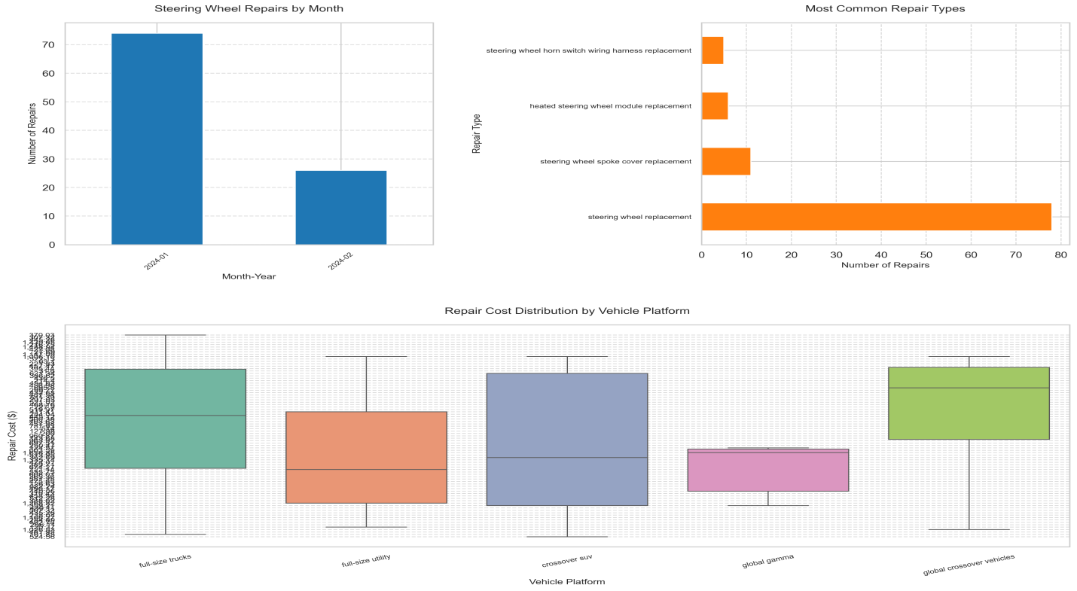

## ****4. Generated Tags & Key Takeaways****

### ****Failure Modes****:

|  |  |  |
| --- | --- | --- |
| Issues | **Examples** | **Frequency** |
| Stitching failure | "Steering wheel stitching is coming undone" | High |
| Leather peeling | "Leather on steering wheel is coming apart" | High |
| Heated wheel failure | "Heated steering wheel doesn’t work" | High |
| Clicking noise | "Clicking noise when turning steering wheel" | Medium |

### ****Key Takeaways****:

**Frequent Steering Wheel Failures**: Material defects and heated module issues are common. **Early Vehicle Repairs**: Majority of issues occur **within 12 months**. **Geographic Impact**: Repairs are widespread in the **US, Canada, and Mexico**, without significant regional clustering. **Manufacturing Insights**: No single plant dominates failure reports, indicating issues arise across multiple production locations.

## ****Conclusion****

This analysis provides stakeholders with a **clear understanding** of steering wheel-related failures, repair trends, and cost impacts. Findings will assist in refining **quality control, predictive maintenance**, and warranty optimizations. Further research should focus on **improving diagnostics, tracking recurring failures**, and enhancing **early defect detection mechanisms**.